**Brooklyn torah gazette**

**For parshas shoftim 5782**

Volume 6, Issue 49 (Whole Number 304) 7 Elul 5782/ September 3, 2022

**The Legacy of Rabbi Chaim Kanievsky, 94, Revered**

**Torah Authority.**

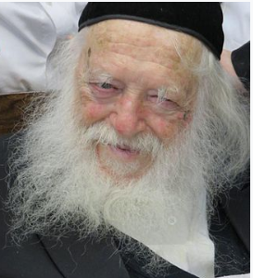 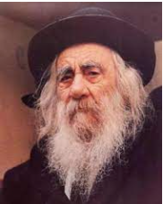

**Rabbi Chaim Kanievsky and his father the Steipler Gaon of blessed memories**

Automobile traffic was shut down in much of central Israel on March 20 as hundreds of thousands of mourners traveled from around the nation by bus and train to Bnei Brak as Rabbi Shmaryahu Yosef Chaim Kanievsky, one of the generation’s leading Lithuanian Torah scholars, was laid to rest.

He passed away at his home in Bnei Brak on Shushan Purim (March 18 2022). He was 94 years old. Rabbi Kanievsky was born in 1928 to Rabbi Yaakov Yisrael and Rebbetzin Pesha Miriam Kanievsky in Pinsk, Poland, today Belarus. His parents met in 1925 after his father—born to a Chernobyl Chassidic family—authored his first work of Torah scholarship, Shaarei Tevunah (“Gates of Understanding”).

Known as the Steipler Gaon after the city of Hornostaypel where he lived as a child, Rabbi Yaakov Yisrael married Miriam Karelitz, sister of Rabbi Avraham Yeshayahu Karelitz (known as the Chazon Ish) in 1926, and took up the lofty responsibilities as rosh yeshivah of the famed Novardok yeshivah, in Pinsk.

The Kanievsky family emigrated to the Holy Land in 1934, where the Steipler Gaon became a leading Torah authority and community leader. From a very young age, Chaim—blessed with a photographic memory and humble spirit—was known as a child prodigy for his Torah insights and assiduous study. In 1948, the 20-year-old rabbinical student at the Lomza Yeshivah in Petach Tikvah was drafted into the newly formed Israel Defense Forces and served near Jaffa during the War of Independence.

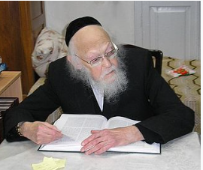

**Rabbi Yosef Shalom Elyashiv of blessed memory**

Soon after, he married Batsheva Elyashiv, the eldest daughter of Jewish jurist Rabbi Yosef Shalom Elyashiv, who later achieved significant renown as a halachic authority. While the young rabbi continued to learn in relative seclusion while authoring works of Torah scholarship, Rebbetzin Kanievsky became well-known for her spiritual gift of blessing, and even as the couple was raising their eight children, hundreds of people would flock to their home in Bnei Brak each week seeking her advice and blessing.

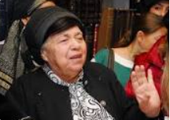

**Rebbetzom Batsheva Kanievsky of blessed memory**

More than 50,000 mourners attended her funeral in 2011. Following his wife’s passing, Rabbi Kanievsky founded and became the rabbi and spiritual leader of Belev Echad, which became a leading nonprofit in Israel providing social services and medical equipment for sick and disabled children and adults.

Until his health deteriorated after contracting Covid in 2020, he would receive thousands of visitors a year at his home, many of whom sought to ‘simply’ catch a glimpse of an old-style Torah scholar immersed in his ageless studies, while others sought a blessing from a Torah scholar.

Insights on a Variety of Torah Subjects For most of his life, Rabbi Kanievsky declined to take on a public leadership role in the community, devoting himself instead to studying and writing on a wide range of often theoretical Talmudic topics of Torah scholarship. Rabbi Kanievsky’s study regimen was very rare, as he reportedly spent up to 17 hours each day in study. He completed an incomprehensible amount of material each year, including the entire Tanach, the Babylonian Talmud, the Jerusalem Talmud, Maimonides’ Mishneh Torah, the Code of Jewish Law, Midrash, Zohar, Tosefta, and the writings of Rabbi Isaac Luria, known as the Ari.

This panoramic view of the fundamental works of halachah and kabbalah, some of which were significantly beyond the ‘curriculum’ of most heads of yeshivahs, granted him expertise in large swaths of the Torah’s corpus. His written works reflect this breadth of knowledge and cover some of the more obscure areas of Jewish law, such as laws particular to the Land of Israel, the Temple, and the sacrifices. Studying these areas also brought him face to face with some of the themes that the [Lubavitcher] Rebbe, Rabbi Menachem M. Schneerson, of righteous memory, had delved into years earlier. In this vein, he weighed into the debate regarding the shape of the branches of the Menorah in the Temple.

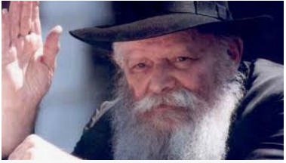

**The Lubavitcher Rebbe of blessed memory**

In line with the Rebbe’s deductions from Rashi’s commentary and Maimonides’ famous illustration, he, too, concluded that the branches of the Temple Menorah were straight rather than curved. He similarly researched and came to agree with the Rebbe’s approach to matters like the superiority of wigs vs. kerchiefs as head-coverings for married women; and the centrality of Maimonides’ code, known as Mishneh Torah, to the entirety of Judaism. Unlike the Shulchan Aruch of Rabbi Yosef Karo which does not codify laws that are inapplicable today, Maimonides covers the entirety of Jewish Law.

Rabbi Kanievsky wrote an extensive commentary on the various sections of Mishneh Torah which pertain to areas of Jewish law not covered by the Shulchan Aruch and its commentaries. Rabbi Kanievsky would actively support the daily study of Rambam as per the Rebbe’s guidance. He also deeply appreciated the work of Chabad scholars who had expanded on the Biblical and Talmudic sources for all of the laws cited by Maimonides.

He similarly called for the public to learn the Shulchan Aruch Harav of the Alter Rebbe, Rabbi Shneur Zalman of Liadi. Perhaps most attesting to his proficiency in Rambam (Maimonides) is a 1967 letter from the Rebbe’s secretariat to Rabbi Azriel Zelig Slonim in Jerusalem asking him to obtain a number of works for the Rebbe’s library, including Rabbi Kanievsky’s Kiryat Melech on Maimonides’ Mishneh Torah.

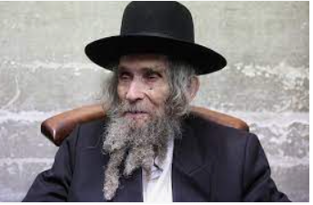

**Rabbi Aharon Leib Shteinman,**

**of blessed memory**

For decades, Rabbi Kanievsky studied and wrote in relative solitude. But following the death of the leading Lithuanian rabbi, Rabbi Aharon Leib Shteinman, in 2017 and countless subsequent requests that he try to fill the void, he began providing public guidance on some issues of the day. But even as he attempted to remain outside the public eye, Rabbi Kanievsky assisted many individuals from all walks of Jewish life.

ChabadLubavitch Rabbi Avraham Berkowitz related how in 1972, his mother-in-law and her family were able to immigrate from Kharkov, Ukraine, then part of the USSR, thanks to the direct help of Rabbi Kanievsky. They needed a family member in Israel who would send an invitation letter to Soviet authorities in Russia in order for them to emigrate.

“My mother-in-law’s family name is Kanevsky, and they did not have family in Israel,” said Berkowitz. “Rabbi Yaakov Kanievsky signed the invitation letter. He instructed his son, Rabbi Chaim Kanievsky, to facilitate the immigration process. “In New York, the Rebbe was actively involved in the entire process,” Berkowitz continued.

“The Rebbe instructed the family to visit Rabbi Kanievsky as soon as they arrived in Israel to thank him for helping them leave the USSR.” They went straight from the airport to visit Rabbi Kanievsky in Bnei Brak and expressed their deepest appreciation to their newfound “family” member, Rabbi Chaim Kanievsky Ztz"l Rabbi Shmaryahu Yosef Chaim Kanievsky is survived by his children: Rabbi Avraham Yeshayah Kanievsky, Leah Koledetski, Rutie Tzivion, Rabbi Shlomo Kanievsky, Brachah Braverman, Deena Epstein and Rabbi Yitzchak Shaul Kanievsky; and numerous grandchildren and great-grandchildren. A daughter, Chana Streinman, predeceased him in 2014. (Chabad.Org)

Reprinted from the Parshas Shoftim 5782 email of R’ Yedidye Hirtenfeld’s whY I Matter, parsha sheet for the Young Israel of Midwood in Brooklyn.

**Rav Avigdor Miller on**

**Talmud Torah Kineged Kulam**



**QUESTION: Why is learning Torah so important that we say תלמוד תורה כנגד כולם, that it’s equal to all other mitzvos?**

**ANSWER:** Torah is considered one of the most important of mitzvos because it makes you. It changes you.

Now, a mitzvah also makes you.  למען תזכרו ועשיתם את כל מצוותי והייתם קדושים – You do mitzvos and you become holy. Every mitzvah makes you kodosh.  But the mitzvah of talmud Torah changes your mind.  And when your mind is changed, that’s the greatest kedusha of all.  And therefore, תלמוד תורה כנגד כולם.

When you think like Hakodosh Boruch Hu thinks, that’s the greatest perfection of a person; it’s the most tremendous change you can make in yourself. And when you’re learning Torah, you’re learning the thoughts of Hashem. That’s how Hashem thinks and He wants you to think that way.

And therefore, learning Torah means you put into your mind the machshavos of the Borei Olam and that’s the greatest of all achievements.  Even when you’re learning Bava Kamma, arba avos nezikin, Hakodosh Boruch Hu is thinking how important it is that every Jew should avoid damaging somebody else’s property and you’re thinking in those details of Hashem’s thoughts.

You’re thinking about how you have to be careful when you go into a synagogue; you want to open the window? Don’t push against the windowpane.  You might push it out and break the pane.  You’re a mazik.  You have to pay for it.  Hakodosh Boruch Hu doesn’t want you to be a mazik.  And you learn that idea not to be a mazik to your fellowman’s property!  How big an ideal that is! You’re thinking like Hakodosh Boruch Hu thinks.  And that’s why תלמוד תורה כנגד כולם; because you’re changing your mind into a mind that thinks like Hakodosh Boruch Hu.

*Reprinted from the August 24, 2022 email of Toras Avigdor (Tape E-1, February 1995)*

**Sheep and Shepherd**

Strayed have Iאבד בקש עבדך כי מצותיך לא שכחתי like a lost sheep; seek our Your servant for I have not forgotten Your commandments (Tehillim 119:176).

If someone loses an inanimate object, such as a wallet or piece of clothing, there is nothing that the lost object can do to be returned to its rightful owner. It cannot speak or move on its own. If sheep are lost from a flock, however, it is not only the shepherd who searches; the sheep, too, search for their master, for they feel their separation and isolation. (R’ Moshe Mordechai Epstein) (Along the Maggid’s Journey)

In Elul, our King, our Shepherd, is in the field. He is searching for us, but we must search for Him as well.

*Reprinted from this week’s email of The Weekly Vort.*

**The Importance of Every**

**Jew’s City Gate**

**From the Talks of the Lubavitcher Rebbe**

**Rabbi Menachem Mendel Schneerson, Zt”l**

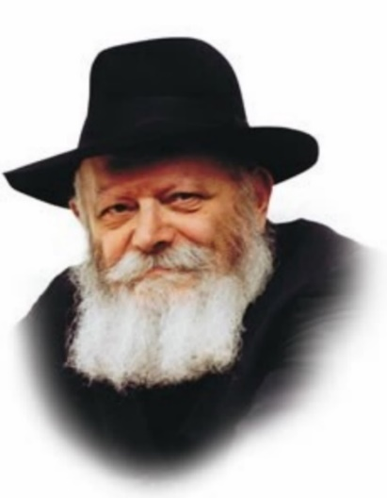

This week's Torah portion, Shoftim, opens with the mitzva: "Judges and officers you shall place at all your gates."

The Torah is eternal; so too are all its commandments. Appointing "judges and officers" thus applies in every age and in all locations, and contains a practical directive for our daily lives.

Every Jew is an entire world, a microcosm of the greater world at large. And just as the world is divided into regions and cities, so too may the individual Jew be said to inhabit various "cities" in which he lives and acts. These "cities" are the thoughts we think, the words we speak, and the deeds and actions we perform.

As with every city, the domains of thought, speech and deed are protected by gates; indeed, it is a mitzva to install them at their entrance. A gate is a portal, a doorway through which all who wish to enter the city must pass. A gate can be opened and closed; when it is firmly shut, no one can intrude.

The Torah's instruction to appoint "judges and officers" at the gates of our individual "cities" is directed to all Jews, young and old. Furthermore, all Jews are endowed with the ability to carry out the command successfully.

When a Jew is aroused to perform good deeds, he must open his "gate" as wide as it will go. But if, G-d forbid, his "city" is in danger of invasion by the Evil Inclination, he must shut the "gate" immediately and refuse it access.

How do we lead a G-dly life? How is it possible to carry out G-d's will? By properly utilizing the limbs and organs with which we are blessed.

A Jew's eyes must be used for reading Jewish books in which is written G-d's laws about how to conduct our lives. Our ears must be used to listen the counsel of our teachers and to hear only words that are appropriate; our nose, to breathe the pure air of Torah and mitzvot, in a wholesome environment where we can breathe freely. Similarly, a Jew's mouth must only open to accept kosher food and drink.

And who is the "judge" who makes these decisions between right and wrong? The "judge" is our intellect, our capacity for rational thought; the "officer" within us makes sure that the "judge's" decisions are enforced.

When we all make the right judgments and obey the Torah's commands, we will merit, with G-d's help, the appointment of the "judges and officers" of the Sanhedrin of the Third Holy Temple, and the complete Redemption with Moshiach, may it be now!

*Reprinted from Issue #484 of L’Chaim for Parshas Shoftim 5757/1997. Adapted for Likutei Sichot, Vol.145*

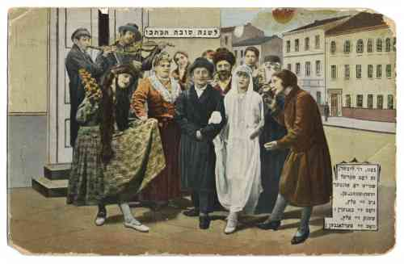

**Rosh Hashana greeting card depicting a Jewish wedding, Verlag Central, Warsaw, ca. 1920s. (RG 122 Postcards and Greeting Cards)**

**Rabbi Berel Wein on**

**Parshat Shoftim 5782**

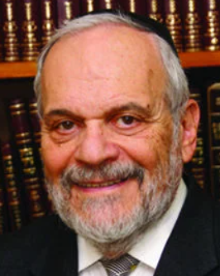

Following the decisions of the court and judges of one’s time, even if one personally disagrees with those judicial conclusions, is the subject of this week’s parsha.  This leads to a later concept in halacha of a *zakein* *mamreh*– a leading scholar, a member of the Sanhedrin itself, who refuses to accept or abide by the majority position and opinion of his colleagues.

There is a normative stance in Jewish life and Judaism that demands and restricts individual freedom and everyone doing their own thing. Every scholar is convinced that his opinion is correct, perhaps even perfectly and exclusively correct. But one must be willing to accept the fact that if most of the scholars disagree, then the law must remain that way even if history later proves them wrong or mistaken.

The majority, like any individual as well, is not infallible. But human society must function according to certain standards and norms and the Torah demands this type of discipline from all responsible leaders and judges. The *zakein* *mamreh* has the right to his own opinion but he has no right to preach it publicly in a way that will split the Jewish society and come to the disastrous situation of there being “two Torahs” present in Jewish society.

There must be a great deal of frustration in the heart of the *zakein* *mamreh*for he is undoubtedly convinced of the correctness of his position. But the Torah does not allow for the correctness of an individual opinion of law to endanger the entire delicate balance of judicial decision and halachic parameters. Again, the forest always trumps the trees in the Jewish view of law and halachic life.

The question now remains: is this true of the majority opinion regarding political and societal issues as well? Many times, in human history has the majority been wrong on crucial life and death issues. Winston Churchill was the lonely voice of warning in the 1930’s when Germany rearmed.

Here in Israel, there have been many instances, especially over the past decade, when the majority has been wrong in its decisions and policies. The rabbis were a minority opinion in the times of the great rebellion against Rome and correctly foresaw the defeat and the destruction of the Temple. The prophet Yirmiyahu was a strident voice of dissension against the majority military and diplomatic policies of the kings of Judah.

It is apparent that there is a significant difference between halachic and judicial decisions and national political and security issues. Eventually, even in these issues, the will of the majority will prevail in a democracy. But the dissenters have an innate right to be heard - and their opinion to be judiciously considered. The tyranny of the majority is a real danger in national matters.

It is much harder in these types of issues to define what is the forest and what are the trees. It is clear though that the concept of *zakein* *mamreh*is limited to those specific halachic issues and procedures that are detailed for us in the Talmudic tractate of Sanhedrin. In other matters, the majority should always force itself to truly listen to the opinion of the minority and the minority has the duty to express those opinions lucidly and publicly.

Shabat shalom.

*Reprinted from the current website of rabbiwein.com*

**Sir Isaac Newton**

**And Judaism**

**By [Bluma Gordon](https://aish.com/authors/306956471?aut_id=4842)**

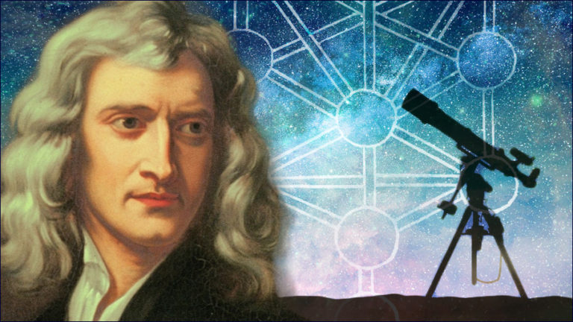

***The scientist’s recently disclosed private papers reveal his deep reverence for ancient Jewish wisdom.***

Sir Isaac Newton was one of the greatest scientists of all time. Some of his most outstanding discoveries include the laws of optics or the physics of light, the three laws of motion, the laws of gravity, and calculus.

He is also famous for his *Principia Mathematica*, the most widely read scientific work of all time, in which he explains the motions of the planets in a single mathematical system. Born in an age that embraced rationalism and shunned religious authority, Newton was also hailed as a hero of his era. Yet, recent divulgement of Newton’s personal writings challenges all common assumptions about his true identity.

**Newton’s Private Beliefs**

Newton’s private beliefs have been under the radar for hundreds of years, perhaps because of their unfavorable reception. Bernard Cohen’s book *Franklin and Newton*discusses the first time scientists discovered Newton’s personal manuscripts:

He quotes John Maynard Keynes, the British great economist: “‘Upon his death in 1727, a very big box of unusual papers was discovered in his room. Bishop Samuel Horsley, who was also a scientist, was asked to inspect the box with view to publication.

He saw the contents with horror and slammed the lid...’ shut.” The recent disclosure of Newton’s private manuscripts revealed that Newton was far from the archetype rationalist he was originally assumed to be.

*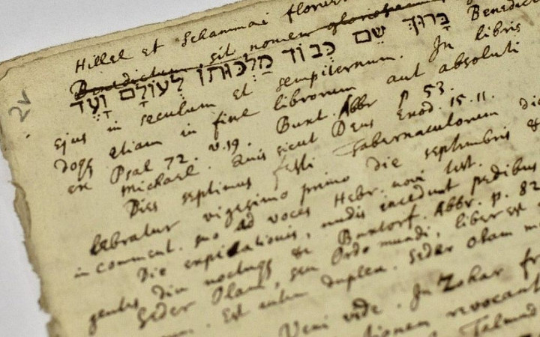A page of Isaac Newton's writing featuring, the prayer, in Hebrew,  
'Blessed is His name for eternity.'*

After being tucked away for 200 years, [Newton’s manuscripts](http://www.southbrunswickchabad.com/page.asp?pageID=%7BEFCC0F2F-5A38-4247-9ADF-D588BFF0E91C%7D&displayAll=1) were finally auctioned off in 1936. Keynes, The Babson family in America, and Israeli Professor Avraham Shalom Yahuda bought the majority of them and donated them to university libraries around the world. These manuscripts have been made available in the past 25 years.

**Newton’s “strange” interests**

It’s no wonder that both Christian and secular-minded scientists who had originally revered Newton had little incentive to publicize their findings. Newton’s manuscripts revealed that he took a keen interest in “archaic” Jewish wisdom.

Newton’s knowledge of Jewish thought was not superficial; he referred to rabbinic works such as the Aramaic Version of Esther, *Vayikra Rabba,* the commentaries of Sa'adia HaGaon, Ibn Ezra, Rashi, Sifra, R. Aharon ibn Hayyim; *Seder Ma'amadot* (about the daily sacrifices) the Bartinurah and Talmudic passages from the Babylonian and Jerusalem Talmud in Latin.

One of Newton’s manuscripts was entitled “On Maimonides,” where he quoted the Latin translation of Maimonides’ *Mishneh Torah. 1*

But the content in Newton’s notes should not really have come as such a big surprise, given the collection of works in his library. Newton kept five works of Maimonides essays in his library.2 He also owned a Latin commentary on Maimonides that references the *Moreh Nevuchim*, The Guide to the Perplexed, Maimonides’ reconciliation of Torah with science and philosophy. This particular work seems to have had a significant impact on Newton’s philosophy.

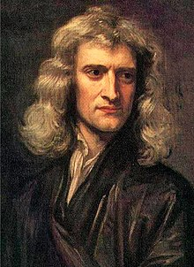

***Sir Isaac Newton***

The harmony between scripture and science was a theme threaded throughout many of Newton’s works, and a means through which he carried out his theological and scientific pursuits.3

**Newton’s beliefs, revealed**

Maynard Keynes, the scholar who studied Newton’s manuscripts, summarized his findings in honor of the 300th anniversary of Newton’s death. Keynes explained that Newton’s beliefs were influenced by Maimonides' philosophy. Keyne’s described Newton as "a Judaic monotheist of the school of Maimonides”. In fact, in his work *The Principia*, Newton rejected the concept of the deity for a belief that closely mirrored the Jewish monotheistic concept of God. (Newton even quotes an element in Maimonides' teachings: that one can only learn about God indirectly, through His actions and His dominion.)4

*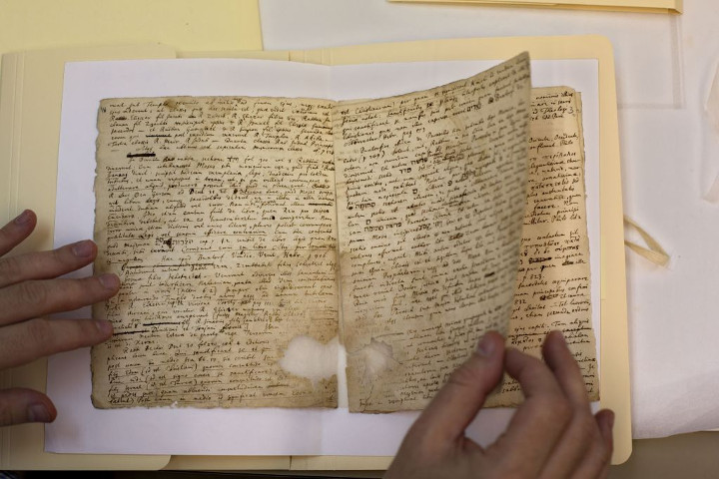****Newton’s theological writings at Israel’s National Library in Jerusalem, October 2014.  
(photo credit: AP Photo/Sebastian Scheiner)***

Newton’s leanings were not limited to the intellectual sphere, and he appears to have kept the seven commandments of the children of Noah that the Torah has given to non-Jews. To quote, in his own words, in *Theological Manuscripts*:

“Although the precepts of Noah are not as perfect as the religion of the Scripture, they suffice for salvation... Indeed, (as the rabbis taught) Jews had admitted into their gates heathens who accepted Noah's precepts, but had not converted to the Law of Moses.”

Newton professed that commandment against eating "the flesh" or "the blood of (live) animals” is because “this religion obliged men to be merciful even to brute beasts.”5

**Newton’s Scientific Works**

**and Maimonides**

What may have irked scientists more than Newton’s private beliefs and practices was how he applied these beliefs to his theological and scientific studies. Parallels of Newton’s philosophy and Maimonides’ teachings are interwoven in his manuscripts.

For example, Newton used Maimonides' "Laws of Sanctification of the New Moon" in his notes on “considerations about rectifying the Julian calendar”.

Newton studied the measurements of Solomon’s Temple and the Third Temple to come to a greater understanding of the earth’s dimensions. He understood that the Temple was a microcosm of the earth and “revealed the works of G-d”, the world’s greatest architect.6

To that end, Newton quoted excerpts from the Latin translation of Maimonides’ De *Cultu Divino*, where he explained the measurements of the Temple.7 Newton also preoccupied himself with studies on the Jewish cubit or the *amah*(measurements used to build the Temple, the tabernacle, and its vessels) and the measurements of The Great Pyramid of Giza, which he believed to have derived from the Jewish cubit.

He wasn’t merely dabbling in mathematics; the accuracy of his analysis of the circumference of the earth and his theory on gravity were dependent on these findings. He recorded his calculations of the Jewish cubit in his work *A Dissertation upon the Sacred Cubit of the Jews and Cubits of the several Nations."*8

Many scientists who feel less than favorably toward Newton’s beliefs and his method of study consider him a fool who dabbled i

In response to the critics, John Maynard Keynes wrote: “There was extreme method in his madness...All his unpublished works... are marked by careful learning, accurate method, and extreme sobriety of statement, they (his controversial works) were nearly all composed during the same 25 years of his mathematical studies.”9

Much of Newton’s private life, as well as some of the drafts of his scientific works, is still hidden from us. It’s perhaps no wonder that he hid his true identity and means of study from the public; he would have likely been ostracized and his scientific discoveries immediately dismissed.

Sarah Dry, author of *The Newton Papers,*notes that gaps in his original draft of *The Principia* suggests that he deliberately concealed them. Says Dry, “And it’s because Newton didn’t want people to know how he had come to his knowledge. I think that might relate to his religious beliefs.”

Newton’s outstanding discoveries single him out as one of the greatest science influencers of all time.

Perhaps we can now add his attempt to reconcile ancient scripture with science as yet another unique, albeit undervalued, accomplishment of Sir Isaac Newton.

1. Newton, Maimonides, and Esoteric Knowledge, Faur Jose, Cross Currents, http://moreshetsepharad.org/media/Newton_Mathematics_and_Esoteric_Knowledge.pdf  
2. Essays on the Context, Nature and Influence of Isaac Newton’s Theology, by James E.Force and Richard H. Popkins, Kulwar Academic publishers, page 3  
3. Newton, Maimonides, and Esoteric Knowledge  
4. *Essays on the Context, Nature, and Influence of Isaac Newton’s Theology*, page 4  
5. *Newton, Maimonides, and Esoteric Knowledge*  
6. *Isaac Newton’s Temple of Solomon and His Reconstruction of the Sacred Cubit*, Tessa Morrison, Springer Science and Business Media, page 36  
7. *Judaism in the Theology of Sir Isaac Newton*, Matt Goldish, Springer Netherlands, https://archive.org/details/springer_10.1007-978-94-017-2014-4  
8. *The Newton you Never Knew.* See also footnote 6  
9. *The Essential Keynes,* by John Maynard Keynes, Penguin Random House.

*Reprinted from this week’s website of aish.com*

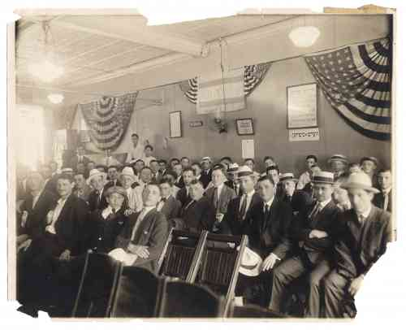

***Immigrant Class for citizenship in New York City (circa 1920) sponsored by the Hewbrew Immigration Aid Society.***